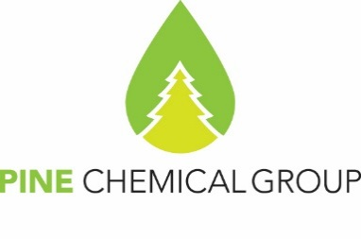

Certificate of Analyses

20.05.2025
PineChemical Group Oy
Helsinki, Finland

Tall Oil PITCH (TOP KOR)

Specification: Technical specification 16217983-006-2018
Date of Production: 19.05.2025
Container no: KRIU2262908
Net weight: 22 410 kgs

Confirmation no: CF25040006 dd 25.04.25
Delivery date: 06 June 2025
Properties | Standard | Analysis
Acid Number, mg of KOH per 1 g of product, max | 70 | 43
Softening point, °C, min | 19 | 34
Viscosity, c | - | 58

Guarantee shelf life is 6 months from the date of production.

PineChemical Group OY representative Natalia Sokolova

