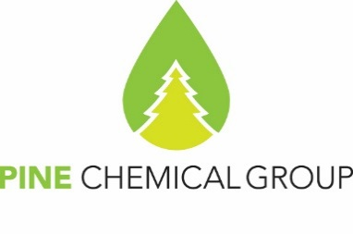

Certificate of Analysis

31.01.2025
PineChemical Group Oy
Helsinki, Finland

SULPHATE TURPENTINE (PTK GRADE)

Specification: Technical conditions 2416-006-18854671-2015
Date of Production: 30.01.2025
Container no.: SEGU8096918
Net weight: 21 200 kgs

Contract no.: Additional Agreement №2 to the Supply Agreement №15/01/2025

Properties | Test results
Appearance | Transparent volatile liquid with no residue and water
Density at 20°C, g/cm³, in a region of | 0.858
Index of refraction | 1.469
Temperature limits of distillation at the pressure of 10/325 Pa (760mm of mercury column)  - initial boiling point, °C, min  - distillate volume fraction up to 170°C, %, min | 155  95
Mass fraction of sulfur, % | 0.011
Mass fraction of the residue from evaporation, %, no more than | 0.04
Acid number, mg KOH /g | 0.04

Conclusion of quality control department: It is hereby certified that the quality of Sulphate Turpentine (PTK grade) mentioned in this certificate is in conformity with the terms and conditions of the contract. In all applications of Sulphate Turpentine (PTK grade) it is the sole responsibility of the buyer to respect and comply with any valid intellectual property rights of third parties

PineChemical Group OY representative Natalia Sokolova

