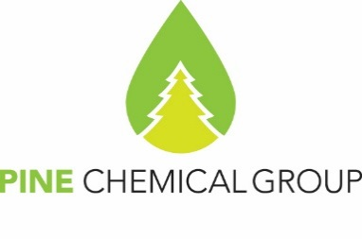

Certificate of Analysis

30.04.2025
PineChemical Group Oy
Helsinki, Finland

Light Tall Oil

Specification: CTO 80241670-018-2017
Date of Production: 29.04.2025
Batch No. 049
Container no: CXTU1114253
Net weight: 20 481 kgs

Properties | Standard | Analysis
Appearance | Light brown to dark color oily liquid
Acid Number, mg of KOH per 1 g of product, min | 70 | 160.1
Density at 50°C, g/cm3 | 0.910-0.970 | 0.903
Mass fraction of unsaponifiables, %, max | 42-45 | 15.3
Resin Acids, % wt., max | 16 | 9.5
Water, %, max | 0.2 | traces

PineChemical Group OY representative
Natalia Sokolova

