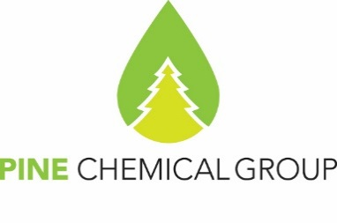

Certificate of Analyses

22.12.2024
PineChemical Group Oy
Helsinki, Finland

SULPHATE TURPENTINE (CRUDE UTL GRADE)

Specification: Technical specification 2416-020-80255613-2021 rev.1
Date of Production: 21.12.2024
Container no.: EXXU3020180
Net weight: 20 291 kgs

Contract no.: Additional Agreement 92 to the Supply Agreement №09/07/2018

Properties | Test results
Appearance | Dark yellow to reddish brown
Density at 20°C, g/cm³ | 0.875
Temperature limits of distillation at the pressure of 10/325 Pa (760mm of mercury column)  - initial boiling point, °C  - distillate volume fraction up to 170°C, % | 154.7  60
Acid number, mg KOH /g | 0.32
Mass fraction of the residue from evaporation, % | 0.094

Conclusion of quality control department: It is hereby certified that the quality of Sulphate Turpentine (Crude UTL grade) mentioned in this certificate is in conformity with the terms and conditions of the contract. In all applications of Sulphate Turpentine (Crude UTL grade) it is the sole responsibility of the buyer to respect and comply with any valid intellectual property rights of third parties

PineChemical Group OY representative
Natalia Sokolova

