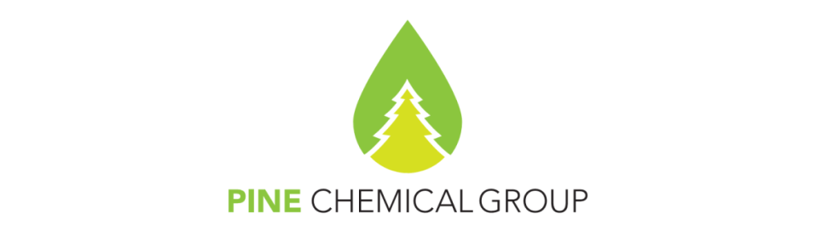

COMMERCIAL INVOICE No: 1425
Date: 31.05.2025
Date of shipment:  May 31st, 2025 |  |  | Due date:  June 15th, 2025 | Contract No:  Supply agreement 05/02/2025 dd 05.02.2025;  Additional Agreement №3
Seller:  PineChemical Group Oy  VAT No FI22303619  Pitkänsillanranta 3 A  00530 Helsinki, Finland  EURASIAN BANK Almaty  IBAN (USD): KZ2694806USD22033530  SWIFT code: EURIKZKA |  |  |  | Buyer:  XXXXXXXXXXX, China  Tel: 86-512-56798579  Fax: 86-512-82177263
Consignor:  PineChemical Group Oy  Pitkänsillanranta 3 A  00530 Helsinki, Finland |  |  |  | Consignee:  XXXXXXXXXXX, China
Currency:  USD |  |  |  | Container No:  GMCU2150539
Country of final destination:  China |  |  |  | Terms of Delivery/Price Term:  CIF XXXXXXXX, China (INCOTERMS - 2010)
No. of  Pkgs | Type of packaging | Full Description of goods |  | Qty,  MT | Units of measure | Unit Value, USD | Total value,  USD
001 | TC, in bulk | Sulphate Turpentine Refined, MAR grade |  | 20.260 | MT | 1425 | 28 870.50
Already prepaid: |  |  |  |  |  |  | -5 700.00
Amount = 23 170.50
VAT 0%, ALV laki 70 §
Total (VAT incl.) = 23 170.50
Please remit the amount USD 23 170.50 US dollars within 15 (fifteen) calendar days from the date of the Bill of Lading.  EUR= 1.1339 USD  USD= 0.8819 EUR  This figure of 25 460.89 EUR is for comparative purposes only and should not be used for payment.  Attorney-in-fact  Natalia Sokolova |  |  |  |  |  |  | Terms of payment:  USD 5 700.00 as a prepayment  The remaining amount shall be paid by the Buyer within 15 calendar days from the date of the Bill of Lading
Customs Tariff Code:
3805109000

